ONLINE BUS TICKET BOOKING SYSTEM

DATABASE MANAGEMENT SYSTEM

Wilson Vidyut Doloy

19BCE1603

CONTENTS

1. Abstract
2. Introduction
3. Database Design
4. ER Model
5. Modules
6. Results and Discussion
7. Conclusion and Future Enhancement
8. References
9. Sample Code

Abstract

This Online Bus Ticket Booking project will provide an Online bus ticket booking platform.

* Leverage the tedious manual ticket booking activity for a customer.
* We can provide a feature that will allow the customer to get a ticket booked without much hassle.



Introduction

Bus Ticket Booking Management System is a computerized system which stores and retrieves data and handles transactions related to Bus travel. This project is aimed at explaining the relevance and importance of DBMS in this system. It is projected towards enhancing the relationship between customers and Bus agencies through the use of DBMS, and thereby making it convenient for the customers to book the Bus tickets as when they require such that they can utilize this software to make reservations.

This software has two parts. First is the customer part and the other is the administrator part. This software utilises DBMS which allows the existing customers to access database and allow new customers to sign up for online access.

The system displays all the Bus details such as Bus no and name.

To book a ticket the system asks the customer to enter his details such as name, age and contact number etc and select their baggage quantity and meal options. Then it books the Bus seat and generates ticket code and traveller id and update this traveller database.

The main purpose of this software is to reduce the manual errors involved in the Bus ticket reservation process and make it convenient for the customers as well as for the Bus officials, to book the seat as when they require such that they can utilize this software to make reservations.

DATABASE DESIGN

SQLite3

Server-less architecture

Self-Contained

Needs Zero-configuration

Dynamic Datatype

ER MODEL

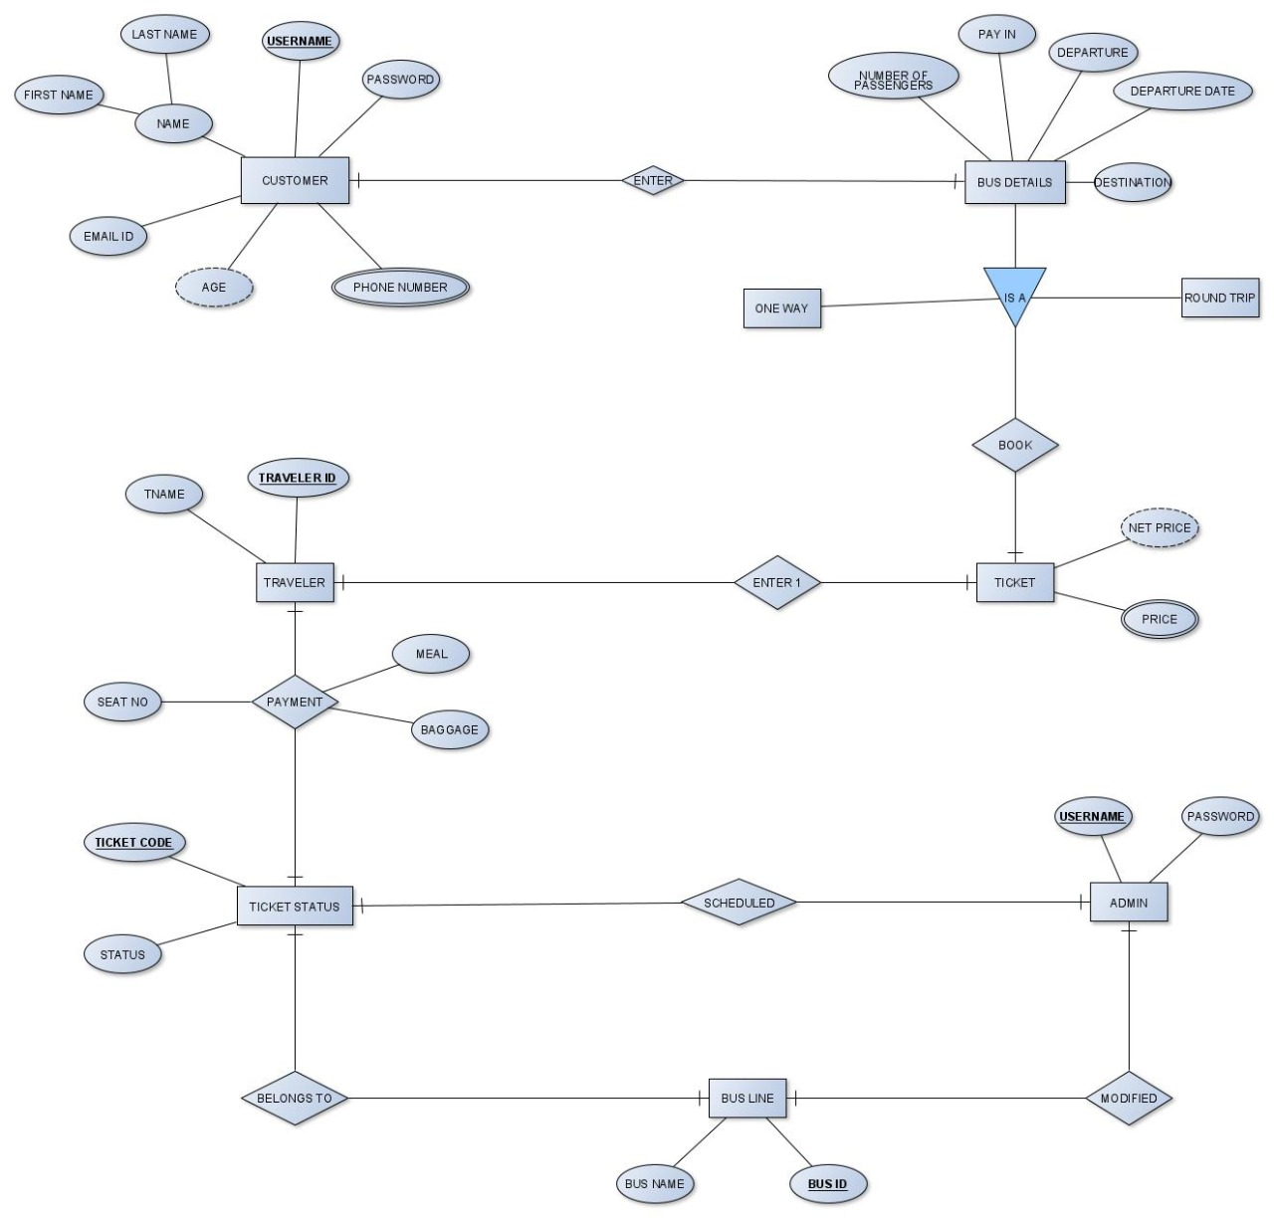

MODULES

* Registration module -

In the registration module if the customer already has an account then they log in into their account or else if it is a new customer then they are asked to create a new account and to enter their details. The customer can also just log in into their account and check their Bus status and they would not be required to enter any code. The details entered by the customer is later used to automatically fill in the traveller details section if the same person is travelling this makes the process faster and more efficient with less errors.

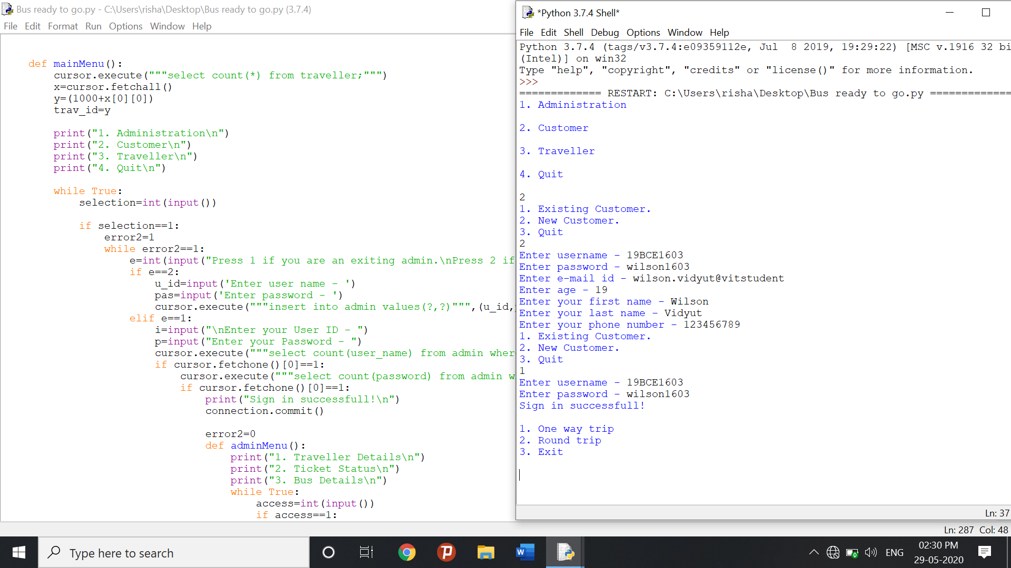

* Administrative module -

The administrative module has an upper hand over all other modules. It allows the administrators to view and edit bus details, check traveller details, check ticket status at regular intervals. It’s like the core of this project. The major operations included in this module are –

1. Create and maintain Bus schedule, fare and timings of the Bus.
2. View the passenger list.
3. Updating the Bus schedule, timings and fare.

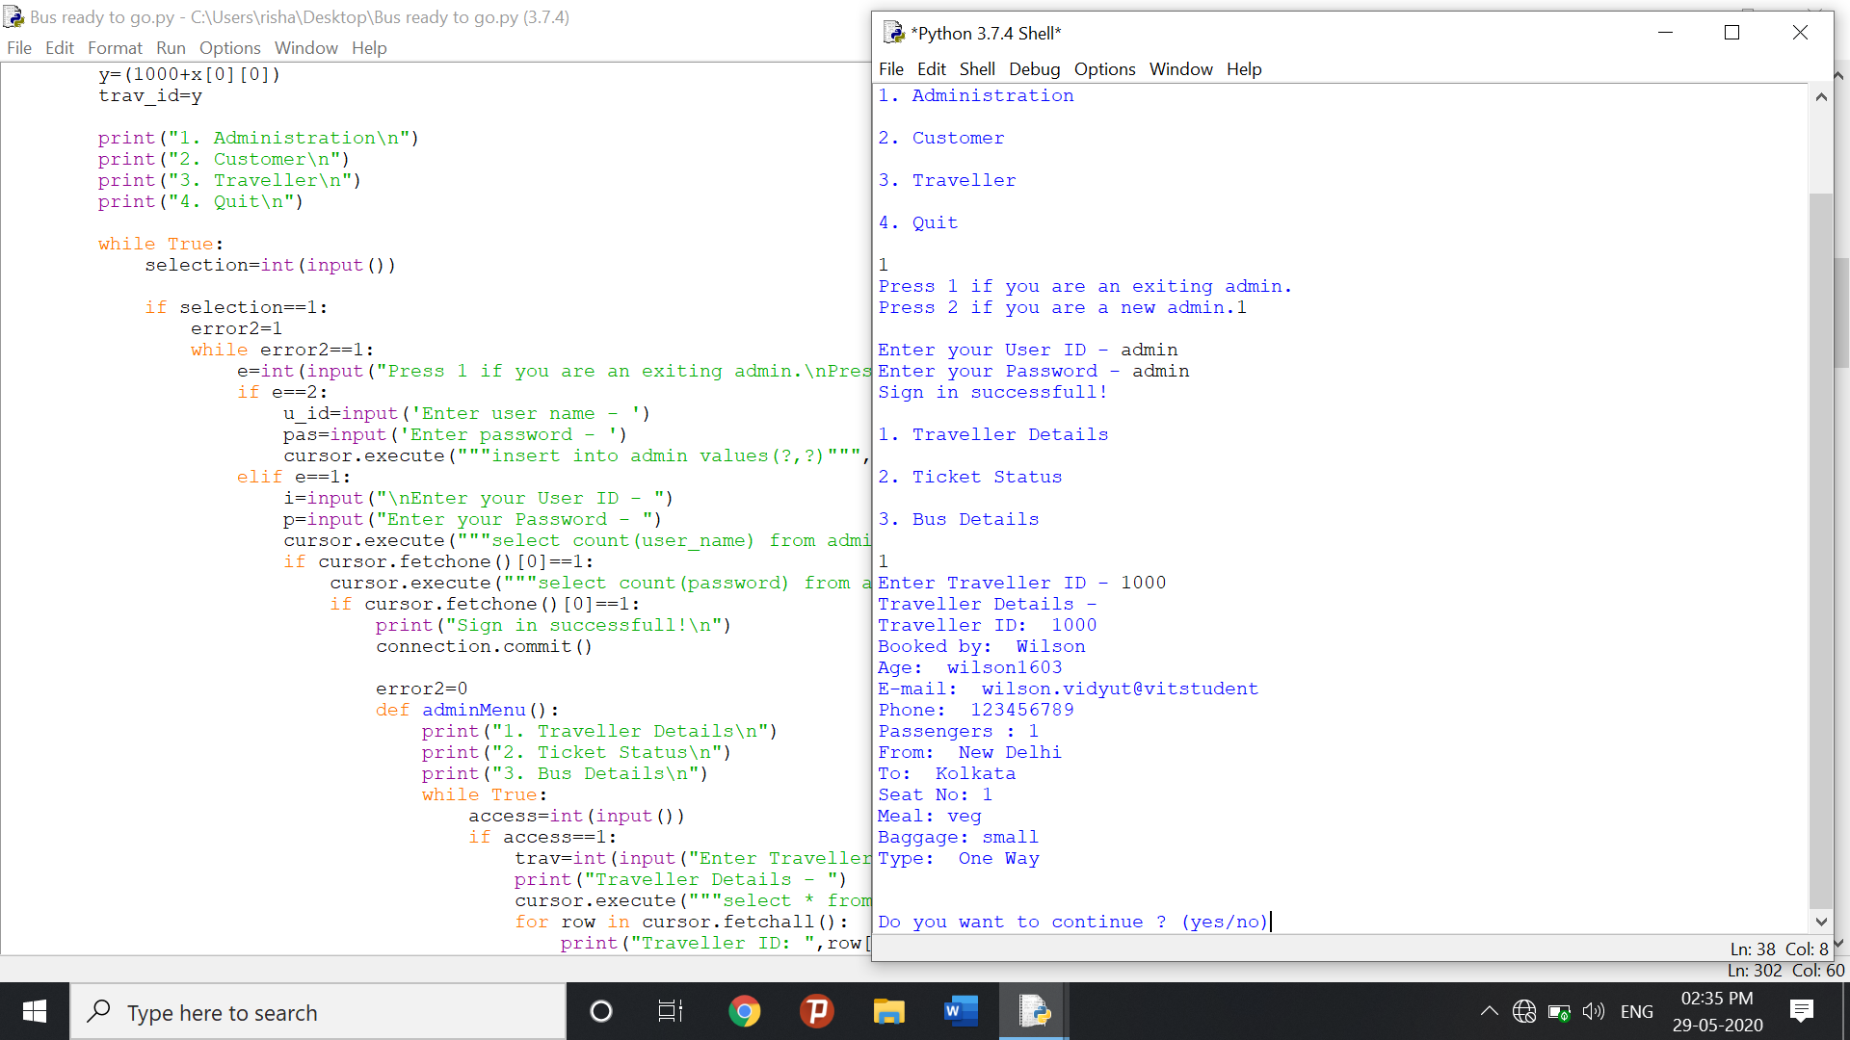

* Passenger module -

This module is meant for the customer, where by logging into their account they will be able to view this panel. The major functions included in this module are -

1. Book for the tickets.
2. Select their seat number and add meal option.

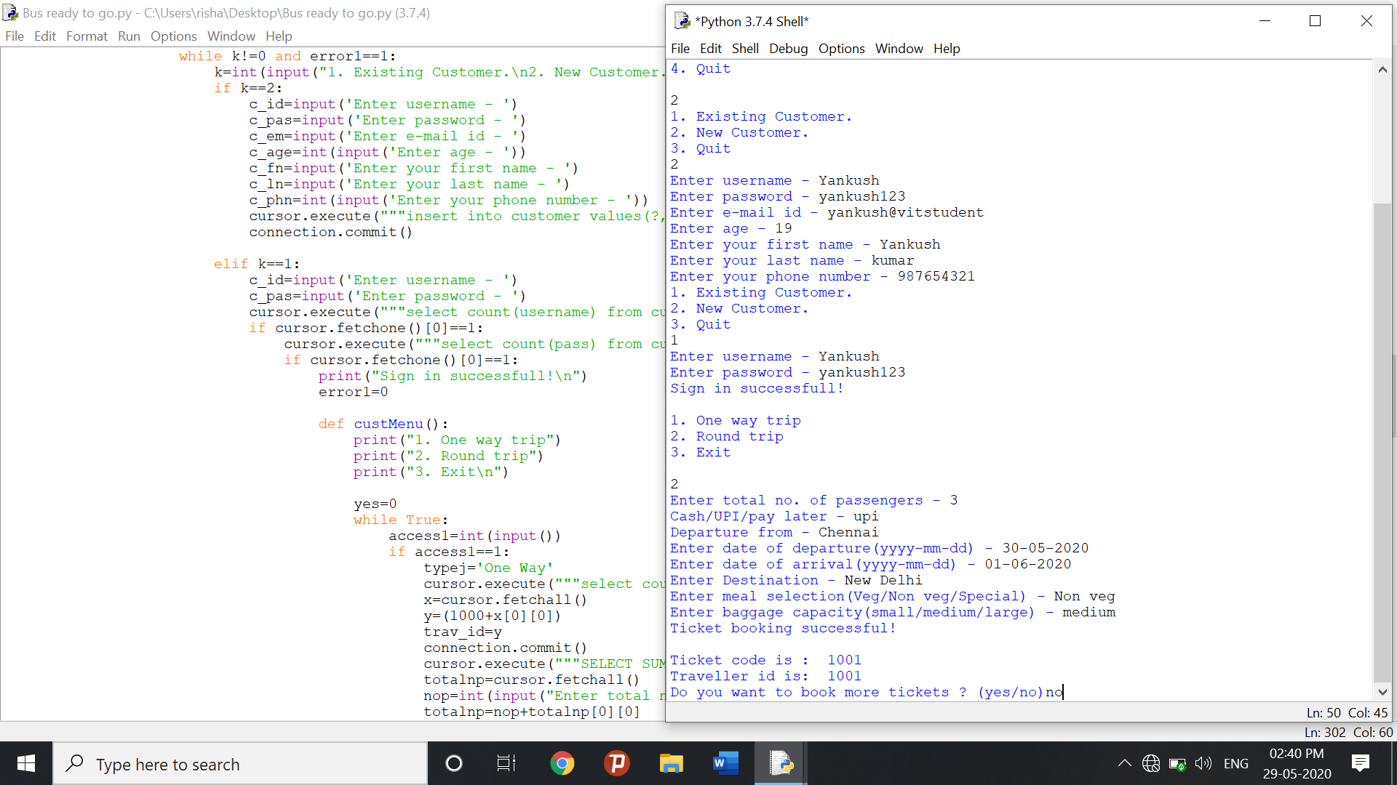

RESULTS AND DISCUSSION

The Bus ticket reservation system is a very time-consuming process. One has to go to the counter to get the tickets. These problems can be made easier for the customers through the creation of an online booking system at their convenience and comfortability. Then can sit at their home and enjoy a wide range of option ranging from meal selection to faster checkout. This is the main reason for developing such a system.

This system will lead to increase in the ticket booking efficiency of the Ticket Booking Agency with little throughput.

This system project is made as user friendly as possible so that anyone can use it with little knowledge of system computers.

The objective of my project is to make easy the ticket booking system of Ticket Booking Agency simple, reliable, user friendly, and fast. Moreover, less time consuming as compared to manual work.



CONCLUSION & FUTURE ENHANCEMENT

In most countries, the use of road transportation is of high demand by the citizens but some problems are associated to this mean of transportation. Typical problems such as the manual booking of tickets (intra and inter trips) from the cashier at bus terminals by long queue; the strenuous and time consumption factor; the tendency of misplacing bus tickets of customer and difficulty in the retrieval of this records.

These problems can be solved by making life easier for the customers through the creation of an online booking system at their convenience and comfortability; this is the main reason for developing such a system. The system is practically of great importance because it reduces the stress of queue to make ticket for booking and rental at the cashier counter; to generate an accurate and detailed profits details and also management of booking seats effectively.

Though we have achieved this much, we have far more miles to go. And we hope to implement it graphically in the future.

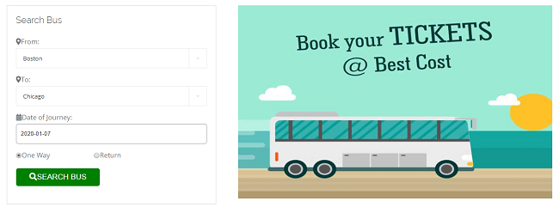

REFERENCES

* [www.sqlitetutorial.net/sqlite-python/](http://www.sqlitetutorial.net/sqlite-python/)
* [www.w3schools.com/python/](http://www.w3schools.com/python/)
* [www.tutorialspoint.com/sqlite/sqlite_python.htm](http://www.tutorialspoint.com/sqlite/sqlite_python.htm)

SAMPLE CODE

import sqlite3, datetime, random

import sys

connection=sqlite3.connect("bus.db")

cursor=connection.cursor()

cursor.execute("""select count(name) from sqlite_master where type='table' and name='admin'""")

if cursor.fetchone()[0]!=1:

cursor.execute("""CREATE TABLE admin(

user_name VARCHAR2(30) primary key,

password VARCHAR2(20) not null);""")

cursor.execute("""CREATE TABLE bus_line(

bus_id number primary key,

bus_name VARCHAR2(30) not null);""")

cursor.execute("""CREATE TABLE ticket_status(

tcode number primary key,

status VARCHAR2(30));""")

cursor.execute("""CREATE TABLE traveller(

traveller_id number,

tname VARCHAR2(60),

tage number,

temail VARCHAR2(30),

tphone number,

nopasg number,

departure VARCHAR2(30),

arrival VARCHAR2(30),

seatn number,

meal VARCHAR(30),

baggage VARCHAR2(30),

typej VARCHAR2(50));""")

cursor.execute("""CREATE TABLE payment(

seat_number number,

meal VARCHAR2(30),

baggage VARCHAR2(30),

tcode number,

traveller_id number);""")

cursor.execute("""CREATE TABLE ticket(

ticketcode number primary key,

net_price number,

price number);""")

cursor.execute("""CREATE TABLE one_way_booking(

no_of_pas1 number,

pay_in1 number,

dep_from1 VARCHAR2(30),

dep_date1 date,

destination1 VARCHAR2(30));""")

cursor.execute("""CREATE TABLE two_way_booking(

no_of_pas2 number,

pay_in2 number,

dep_from2 VARCHAR2(30),

dep_date2 date,

ret_date date,

destination2 VARCHAR2(30));""")

cursor.execute("""CREATE TABLE customer(

username VARCHAR2(30) primary key,

pass VARCHAR2(30) not null,

email VARCHAR2(30),

age number not null,

first_n VARCHAR2(30),

second_n VARCHAR2(30),

phone number);""")

cursor.execute("""insert into bus_line values(100,'Pratik Travels-1')""")

cursor.execute("""insert into bus_line values(101,'Pratik Travels-2')""")

cursor.execute("""insert into bus_line values(102,'Pratik Travels-3')""")

cursor.execute("""insert into bus_line values(103,'Pratik Travels-4')""")

cursor.execute("""insert into bus_line values(104,'Rose Travels-1')""")

cursor.execute("""insert into bus_line values(105,'Rose Travels-2')""")

cursor.execute("""insert into bus_line values(106,'Rose Travels-3')""")

cursor.execute("""insert into bus_line values(107,'Rose Travels-4')""")

cursor.execute("""insert into bus_line values(108,'Rani Travels-1')""")

cursor.execute("""insert into bus_line values(109,'Rani Travels-2')""")

cursor.execute("""insert into bus_line values(110,'Rani Travels-3')""")

cursor.execute("""insert into bus_line values(111,'Rani Travels-4')""")

cursor.execute("""insert into one_way_booking (no_of_pas1) VALUES (0)""")

cursor.execute("""insert into two_way_booking (no_of_pas2) VALUES (0)""")

print("Database successfully created !")

else:

def mainMenu():

cursor.execute("""select count(*) from traveller;""")

x=cursor.fetchall()

y=(1000+x[0][0])

trav_id=y

print("1. Administration\n")

print("2. Customer\n")

print("3. Traveller\n")

print("4. Quit\n")

while True:

selection=int(input())

if selection==1:

error2=1

while error2==1:

e=int(input("Press 1 if you are an exiting admin.\nPress 2 if you are a new admin."))

if e==2:

u_id=input('Enter user name - ')

pas=input('Enter password - ')

cursor.execute("""insert into admin values(?,?)""",(u_id,pas))

elif e==1:

i=input("\nEnter your User ID - ")

p=input("Enter your Password - ")

cursor.execute("""select count(user_name) from admin where user_name=?""",(i,))

if cursor.fetchone()[0]==1:

cursor.execute("""select count(password) from admin where password=?""",(p,))

if cursor.fetchone()[0]==1:

print("Sign in successfull!\n")

connection.commit()

error2=0

def adminMenu():

print("1. Traveller Details\n")

print("2. Ticket Status\n")

print("3. Bus Details\n")

while True:

access=int(input())

if access==1:

trav=int(input("Enter Traveller ID - "))

print("Traveller Details - ")

cursor.execute("""select * from traveller where traveller_id=(?)""",(trav,))

for row in cursor.fetchall():

print("Traveller ID: ",row[0])

print("Booked by: ",row[1])

print("Age: ",row[2])

print("E-mail: ",row[3])

print("Phone: ",row[4])

print("Passengers :",row[5])

print("From: ",row[6])

print("To: ",row[7])

print("Seat No:",row[8])

print("Meal:",row[9])

print("Baggage:",row[10])

print("Type: ",row[11])

print("\n")

cont=input("Do you want to continue ? (yes/no)")

if cont=='yes':

adminMenu()

else:

print("Thank you for letting us serve you. Have a nice day ahead!\n")

mainMenu()

elif access==2:

tic=input("Enter Ticket Code - ")

print("Ticket Details - ")

cursor.execute("""select * from ticket_status where tcode=(?)""",(tic,))

for row in cursor.fetchall():

print("Ticket Code: ",row[0])

print("Status: ",row[1])

print("\n")

cont=input("Do you want to continue ? (yes/no)")

if cont=='yes':

adminMenu()

else:

print("Thank you for letting us serve you. Have a nice day ahead!")

break

elif access==3:

bus=input("Enter Bus ID - ")

print("Bus Details - ")

cursor.execute("""select * from bus_line where bus_id=(?)""",(bus,))

for row in cursor.fetchall():

print("Bus ID: ",row[0])

print("Bus Name: ",row[1])

print("\n")

cont=input("Do you want to continue ? (yes/no)")

if cont=='yes':

adminMenu()

else:

print("Thank you for letting us serve you. Happy a nice day ahead!")

sys.exit(0)

else:

print("Invalid choice. Enter 1-4")

adminMenu()

break

adminMenu()

else:

print("Incorrect passoword. Please retry! ")

else:

print("Incorrect User ID. Please retry! ")

elif selection==2:

error1=1

k=1

while k!=0 and error1==1:

k=int(input("1. Existing Customer.\n2. New Customer.\n3. Quit\n"))

if k==2:

c_id=input('Enter username - ')

c_pas=input('Enter password - ')

c_em=input('Enter e-mail id - ')

c_age=int(input('Enter age - '))

c_fn=input('Enter your first name - ')

c_ln=input('Enter your last name - ')

c_phn=int(input('Enter your phone number - '))

cursor.execute("""insert into customer values(?,?,?,?,?,?,?)""",(c_id,c_pas,c_em,c_age,c_fn,c_ln,c_phn,))

connection.commit()

elif k==1:

c_id=input('Enter username - ')

c_pas=input('Enter password - ')

cursor.execute("""select count(username) from customer where username=(?)""",(c_id,))

if cursor.fetchone()[0]==1:

cursor.execute("""select count(pass) from customer where pass=(?)""",(c_pas,))

if cursor.fetchone()[0]==1:

print("Sign in successfull!\n")

error1=0

def custMenu():

print("1. One way trip")

print("2. Round trip")

print("3. Exit\n")

yes=0

while True:

access1=int(input())

if access1==1:

typej='One Way'

cursor.execute("""select count(*) from traveller;""")

x=cursor.fetchall()

y=(1000+x[0][0])

trav_id=y

connection.commit()

cursor.execute("""SELECT SUM(no_of_pas1)FROM one_way_booking""")

totalnp=cursor.fetchall()

nop=int(input("Enter total no. of passengers - "))

totalnp=nop+totalnp[0][0]

price=random.choice([500,600,700,800,900,1000])

pay=input("Cash/UPI/pay later - ")

dep=input("Departure from - ")

date=input('Enter date of departure(yyyy-mm-dd) - ')

dest=input("Enter Destination - ")

meal=input("Enter meal selection(Veg/Non veg/Special) - ")

if meal.lower()=='veg':

pric=200

elif meal.lower()=='non veg':

pric=300

elif meal.lower()=='special':

pric=400

total_price=price+pric

bag=input("Enter baggage capacity(small/medium/large) - ")

cursor.execute("""insert into one_way_booking values(?,?,?,?,?)""",(nop,pay,dep,date,dest))

print("Ticket booking successful!\n")

cursor.execute("""insert into payment(seat_number,meal,baggage,tcode,traveller_id) values(?,?,?,?,?)""",(totalnp,meal,bag,y,trav_id))

cursor.execute("""insert into ticket values(?,?,?)""",(y,total_price,price))

print("Ticket code is : ",y)

print("Traveller id is: ",trav_id)

if pay.lower()=='pay later':

cursor.execute("""insert into ticket_status values(?,?)""",(y,'Not Confirmed'))

elif pay.lower()=='cash' or pay.lower()=='upi':

cursor.execute("""insert into ticket_status values(?,?)""",(y,'Confirmed'))

cursor.execute("""select * from customer where username=(?)""",(c_id,))

for row in cursor.fetchall():

ta=row[1]

te=row[2]

tfn=row[4]

tp=row[6]

i=0+yes

cursor.execute("""insert into traveller(traveller_id,tname,tage,temail,tphone,nopasg,departure,arrival,seatn,meal,baggage,typej) values (?,?,?,?,?,?,?,?,?,?,?,?)""",(y,tfn,ta,te,tp,nop,dep,dest,totalnp,meal,bag,typej))

connection.commit()

connection.commit()

cont=input("Do you want to book more tickets ? (yes/no)")

if cont=='yes':

yes=yes+1

custMenu()

else:

print("Thank you for letting us serve you. Happy journey!")

break

break

elif access1==2:

cursor.execute("""select count(*) from traveller;""")

x=cursor.fetchall()

y=(1000+x[0][0])

trav_id=y

typej='Round Trip'

cursor.execute("""SELECT SUM(no_of_pas2)FROM two_way_booking""")

totalnp=cursor.fetchall()

nop=int(input("Enter total no. of passengers - "))

totalnp=nop+totalnp[0][0]

price=random.choice([900,1200,1500,1800,2000,2500])

pay=input("Cash/UPI/pay later - ")

dep=input("Departure from - ")

date1=input('Enter date of departure(yyyy-mm-dd) - ')

date2=input('Enter date of arrival(yyyy-mm-dd) - ')

dest=input("Enter Destination - ")

meal=input("Enter meal selection(Veg/Non veg/Special) - ")

if meal.lower()=='veg':

pric=200

elif meal.lower()=='non veg':

pric=300

elif meal.lower()=='special':

pric=400

total_price=price+pric

bag=input("Enter baggage capacity(small/medium/large) - ")

cursor.execute("""insert into two_way_booking values(?,?,?,?,?,?)""",(nop,pay,dep,date1,date2,dest))

print("Ticket booking successful!\n")

cursor.execute("""insert into payment(seat_number,meal,baggage,tcode,traveller_id) values(?,?,?,?,?)""",(totalnp,meal,bag,y,trav_id))

cursor.execute("""insert into ticket values(?,?,?)""",(y,total_price,price))

print("Ticket code is : ",y)

print("Traveller id is: ",trav_id)

if pay.lower()=='pay later':

cursor.execute("""insert into ticket_status values(?,?)""",(y,'Not Confirmed'))

elif pay.lower()=='cash' or pay.lower()=='upi':

cursor.execute("""insert into ticket_status values(?,?)""",(y,'Confirmed'))

cursor.execute("""select * from customer where username=(?)""",(c_id,))

for row in cursor.fetchall():

ta=row[1]

te=row[2]

tfn=row[4]

tp=row[6]

i=0+yes

cursor.execute("""insert into traveller(traveller_id,tname,tage,temail,tphone,nopasg,departure,arrival,seatn,meal,baggage,typej) values (?,?,?,?,?,?,?,?,?,?,?,?)""",(y,tfn,ta,te,tp,nop,dep,dest,totalnp,meal,bag,typej))

connection.commit()

connection.commit()

cont=input("Do you want to book more tickets ? (yes/no)")

if cont=='yes':

custMenu()

else:

print("Thank you for letting us serve you. Happy journey!")

break

break

elif access1==3:

break

else:

print("Invalid choice. Enter 1, 2 or 3")

custMenu()

custMenu()

else:

print("Incorrect passoword. Please retry! ")

else:

print("Incorrect User ID. Please retry! ")

break

elif selection==3:

t_id=input('Enter traveller id - ')

print("Traveller Details: ")

cursor.execute("""select * from traveller where traveller_id=(?)""",(t_id,))

for row in cursor.fetchall():

print("Traveller ID: ",row[0])

print("Booked by: ",row[1])

print("Age: ",row[2])

print("E-mail: ",row[3])

print("Phone: ",row[4])

print("From: ",row[5])

print("To: ",row[6])

print("Seat No:",row[7])

print("Meal:",row[8])

print("Baggage:",row[9])

print("Type: ",row[10])

print("\n")

print("Ticket Details - ")

cursor.execute("""select * from ticket_status where tcode=(?)""",(t_id,))

for row in cursor.fetchall():

print("Ticket Code: ",row[0])

print("Status: ",row[1])

print("\n")

cursor.execute("""select seat_number,meal,baggage from payment where tcode=(?)""",(t_id,))

for row in cursor.fetchall():

print("Seat number: ",row[0])

print("Meal: ",row[1])

print("Baggage: ",row[2])

cursor.execute("""select net_price,price from ticket where ticketcode=(?)""",(t_id,))

cont=input("Do you want to continue ? (yes/no)")

if cont=='yes':

mainMenu()

else:

print("Thank you for letting us serve you. Have a nice day ahead!\n")

break

elif selection==4:

sys.exit()

else:

print("Invalid choice. Enter 1-4")

exit

mainMenu()

break

mainMenu()

connection.commit()

connection.commit()

connection.close()